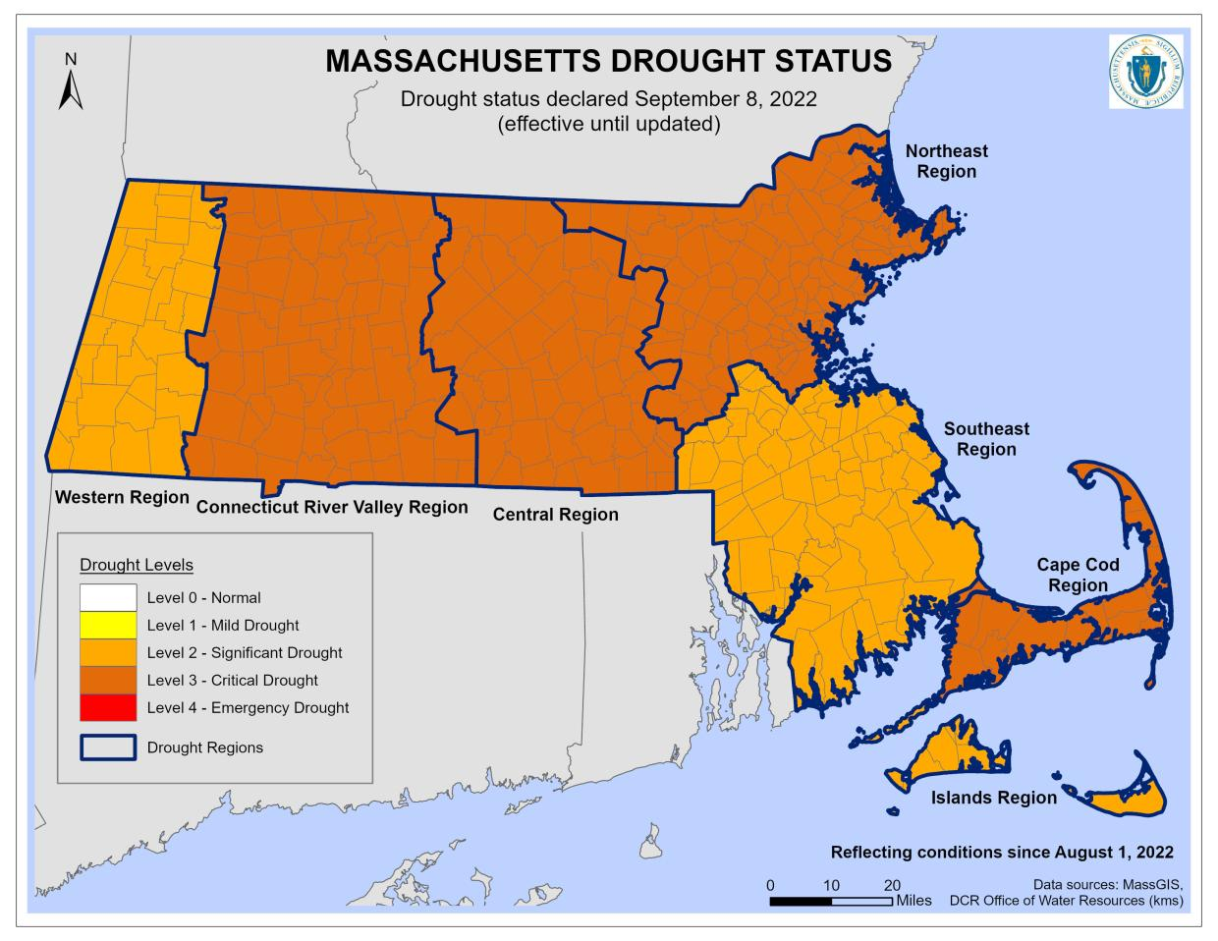
September 8, 2022: Energy and Environmental Affairs (EEA) Secretary Beth Card today declared that except for the Southeast Region that saw improvement at the regional scale, all other regions within the Commonwealth will remain at their current drought levels. This includes the Cape Cod, Connecticut River Valley, Northeast, and Central Regions remaining at a Level 3-Critical Drought, and the Islands and Western Regions remaining at a Level 2-Significant Drought. The Southeast Region has been upgraded to Level 2 – Significant Drought from a Level 3-Critical Drought. Read more on our drought status page. This declaration will remain in effect till the next declaration in Mid-September.
Level 2 Significant Drought- Limit all nonessential* outdoor water use to hand-held hoses or watering cans, to be used only after 7 PM or before 6 AM.
*Essential uses are defined by MassDEP as uses required: a) for health or safety regulations; b) by regulation; c) for the production food and fiber; d) for the maintenance of livestock; or e) to meet the core functions of a business. Nonessential uses are those other than essential uses.

