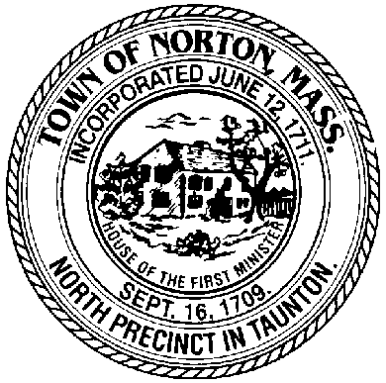
OFFICE OF THE TOWN CLERK

70 East Main Street 508-285-0230
Norton, MA 02766 www.nortonma.org 508-285-0297 (fax)
townclerksoffice@nortonmaus.com

To: Board of Registrars
Republican and Democratic Town Committees
Town Clerk’s Office – Please post in accordance with Open Meeting Law

From: Lucia B. Longhurst, Town Clerk

Date: September 6, 2017

RE: Testing of Voting Equipment

TESTING OF VOTING EQUIPMENT

The test for the ballot tabulating equipment for the Special State Primary Election on Tuesday, September 19, 2017 will be held on Monday, September 11, 2017 beginning at 9:00 AM

Testing will be held at the Norton Town Hall, Board of Selectmen’s Meeting Room, 1st floor, 70 East Main Street, Norton, MA 02766. There has been no change in type of voting equipment used by the Town of Norton since the last election.

