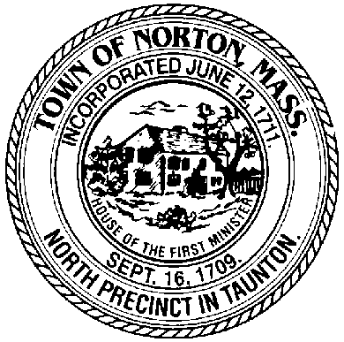
TOWN OF NORTON

Norton Cable Access Corporation

MINUTES

Date: May 13, 2016 Time: 11:00 PM

Location: Norton Cable Access Temporary Studio
Norton Crossing 184 West Main St – Suite 8 2nd Floor

Members & Staff Present: Charlene Fisk , Jason Benjamin, Michael Kramer, Ellen Kane, Ray Cord

Members Not Present: Victor Rodriguez, Paul Driscoll

The meeting called to order at 11:07 PM.

Meeting Motions / Actions and Summary of Discussions:

Review of April Meeting Minutes

Motion made by Ray Cord to accept the April meeting minutes.
Motion seconded by Mike Kramer.

Motion approved unanimously, without discussion.

Treasurer’s Report

Ray reviewed he financial report for April. Ray explained and compared last year’s report to this year’s expenses and there were no unexpected expenses or discrepancies. The current balance as of April is $73,000.

Motion to approve: Charlene Fisk.
Seconded by: Ellen Kane.

Station Manager’s Report

Summary of Event Coverage
Eighteen (18) events were covered.

Town Meeting Update

Jason reviewed the latest town meeting broadcast issues. The broadcast was live via the internet and not the fiber plant that has been installed from the High School to the Studio. When a test was conducted on the fiber line, there were some issues with the signal from the High School to the Middle school ending at the Studio. Jason is planning on having a meeting with Comm-tract to discuss boosting the signal. Until this signal issue is resolved, the meeting at the High School will be broadcast over the internet.

Founders Day

Jason reviewed the last few years on ways the studio participated in Founder’s Day. We discussed options to change the concept that would be a part of this year’s Founder’s Day. Members provided Jason with different options for giveaways and fun activities for the community to participate in when they visit the Norton Media booth.

Community Participation

The studio covered four proposition 2 ½ related programs. Three of these shows originated at the studio. The programs reflected both sides of the proposal. These programs generated a historic 9,250 page loads off the website in one week.
New Business

Planning Concerns Pending Town Meeting

The board discussed some of their concern with the pending 2 ½-proposition town meeting. Access to rental equipment is the main concern with graduation season coming up. It was decided to draft a letter and notify the town meeting committee about the studio’s limitations on covering this pending event live. Jason will draft the letter and take input from other board members before sending the letter.

Sponsorship of Founder’s Day

After a review of last years Foumder’s Day sponsorship and this year’s options, the board agreed to donate $600.00 to the Founder’s Day fundraiser.

Motion made by Ray Cord to accept the $600.00 donation to Founder’s Day.
Motion seconded by Mike Kramer.

Motion approved unanimously, without further discussion.

Old Business

Update on grant applications

Jason informed the board that there were a few applications for this cycles grant. The board agreed to move up the next regular scheduled meeting from June 10th to June 3rd. This will allow the board to hear all the applications and five the board time to issue checks to the recipients before summer recess.

Contact Public Meeting

After a brief discussion, the board agreed to set a date in the Fall of 2016 to hear public comments on the upcoming contract with Comcast.

With no further business before the board, Ray Cord made a motion to adjourn.
Paul Driscoll seconded the motion.

Meeting adjourned at 12:05 PM.

List of Documents and Other Exhibits used at Meeting:
- Station Managers Report
- Treasurer’s Report

Minutes approved by the committee on : 06-03-16
Minutes Approved by Committee on: __________________________________________.

Respectfully submitted,

Signatures:

Secretary _______________________________________
Charlene A. Fisk, Norton Cable Access Corp.

Chairperson _______________________________________
Victor Rodriguez, Norton Cable Access Corp.

