Community Playground & Tricentennial Park
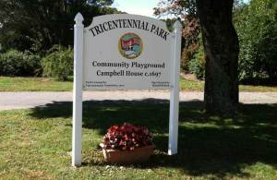
217 West Main Street, Norton MA
Map and Directions
The community playground is maintained by the Norton Parks and Recreation Department and Ribeiro Bros. The Tricentennial Park is maintained by the Tricentennial Committee.
Visit the Community Playground & Tricentennial Park photo gallery

